DIS-PAC-Poly-Fiji-War Club

# FIJIAN THROWING WAR CLUB ULA TAVATAVA

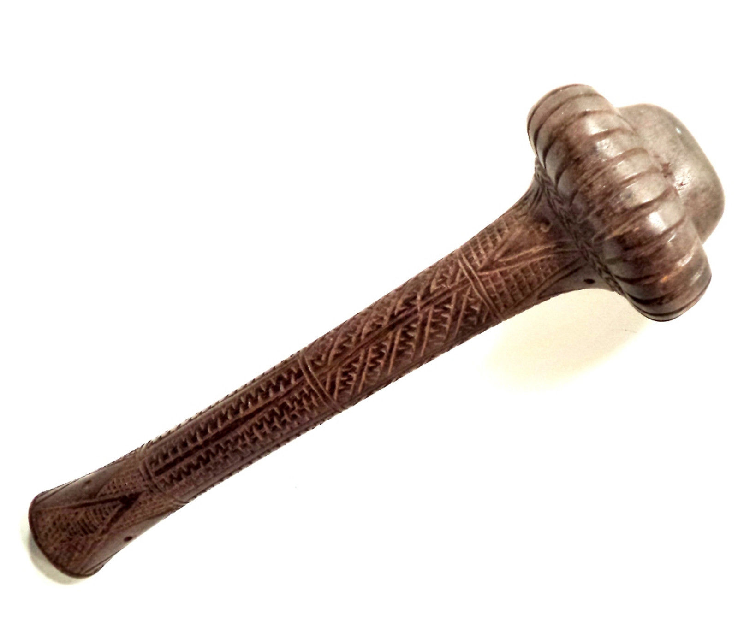

A common type of Ula with flanges or lobes on the head of the club"

"Ula were made for throwing at an enemy and often a Fijian warrior would have several either tucked into his belt or close to hand. It is for this reason they are the most common type of Fijian war club.. Ula come in many different forms."

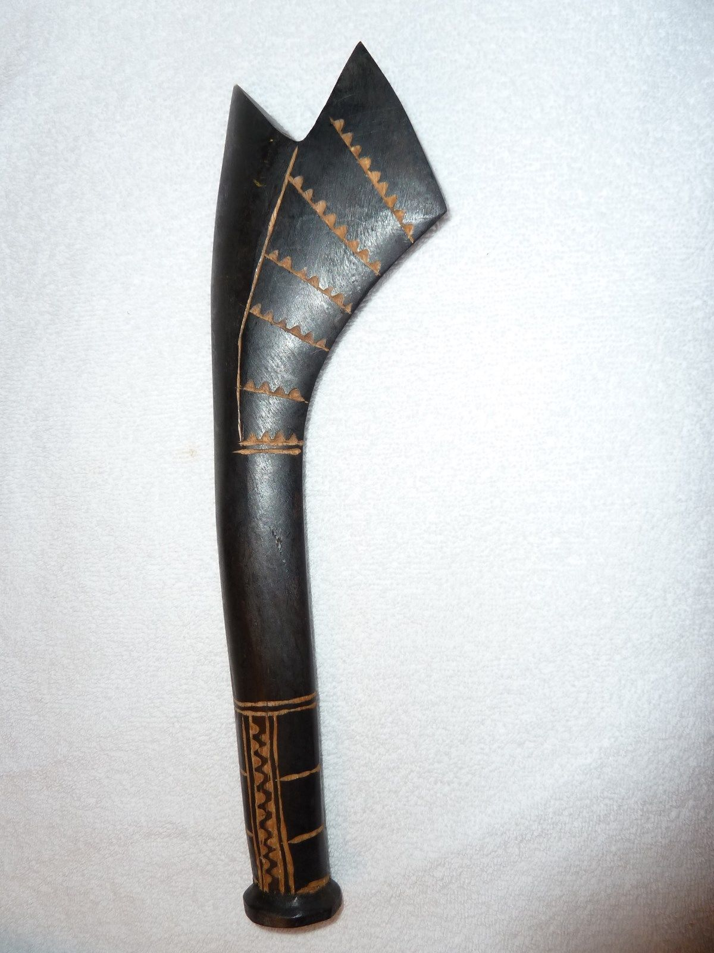

handcrafted via via gata war weapon replica is of the highest quality pieces we've received! Carved and etched from Fijian vesi wood, this replica measures 12" in length. Features special tribal etchings. A gorgeous piece!